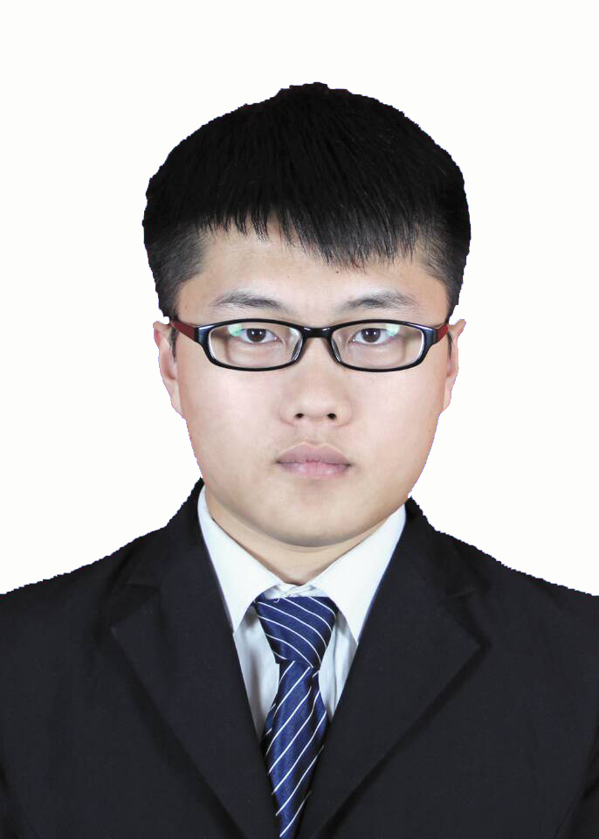
Resume of Bichao Xue
BirthDay: February 1996
Education: Taiyuan University of Science and Technology
Major: Internet of Things Engineering Graduation Date: 2018.7
Contact information: 18434391952 E-mail: 18434391952@163.com
Job Intention
Work Location: Beijing
Occupation: Development /(automation) test engineer
Self evalution
Self-evaluation: I am hard-working and have team work spirit.Excellent professional knowledge, have a strong interest in their own major.To work seriously, diligent, can independently learn to understand a variety of new things.Good social skills, excellent organization and coordination skills.In study, I pay attention to the combination of theory and practice, and
have considerable practical operation ability. I can study and work independently.
Professional Skills
Familiar with some common commands of Linux operating system, shell script;
Familiar with programming languages such as Python, java, c++;
Skilled in the assembly of servers, skilled in the use of various PCI cards, as well as a variety of Memory, CPU and other configurations;
Be able to use Gaussdb, MySQL and Oracle databases; be familiar with adding, deleting, modifying and checking
databases with basic SQL statements; be familiar with using benchmarksql and sysbench;
Proficient in git, GitHub and other code hosting platforms;
Familiar with software testing process, master software testing theories and methods, design and write test cases, be able to use equivalence class, boundary value analysis, decision table analysis, scenario method to design test cases, and
write relevant documents of test reports;
Proficient in test case and bug management, defect submission, defect follow-up management and regression testing;
Use the Python+pytest framework for automated testing;
A bility to read API documentation and requirements and stress test using MPx;
Understand the network transmission in the TCP-IP model based on computer network; Cet-4, proficient in reading relevant technical English documents; Familiar with docker and basic use of k8s;
Work Experience
April 2021 -- present
Huawei, test and development, mainly responsible for gaussdb test design, feature testing, performance testing and automated testing;
From March 2020 to April 2021
Beijing Megvii Technology Co., LTD., software testing.Mainly responsible for testing the functions, interfaces, performance and interface automation of Brainpp;
July 2018 - March 2020
Lenovo Computer Co., LTD. Server software test engineer.Mainly responsible for LXPM, UXSP, BVT, LXCE and other functional tests; OSE partial stress test;RAS and other automated tests.Able to skillfully use various tools and successfully complete various test tasks.
Project
Project 1: gaussdb Test Group (gaussdb, opengauss)
Time: 2021.4-present
Main Responsibilities:
1. Test design;
2. Requirements review discussion;
3. Characteristic test, performance test;
4. Closed-loop tracking processing of downstream problems;
5. Daily CI analysis;
Test tools:
python+shell+linux+benchmarksql+sysbench pdf.youdao
Project 2: Engineering Capability System Quality Assurance Group (BrainPP, Megstudio, etc.)
Time: 2020.3-2021.4
Main Responsibilities:
1． Requirement analysis review discussion;
2． Technical analysis review discussion;
3． Test case design;
4． Test scheduling communication;
5． Use postman for interface testing;
6． Perform performance related tests using jmeter;
7． Using python to write testing tools to improve testing efficiency;
8． Write interface automation tests in python;
Test tool:
python+Docker+postman+jmete+k8s
Project 3: PA-Software Department
Time: January, 2019.1-present
Main Responsibilities:
1. Test the OS and PCI adapter FW/driver refresh.
2. OS certification and compatibility test;
3. Use VNC, SSH, and ipmi to remotely control the server.
Test tool:
Python+java+Qtester+ipmi+putty+shell
Project 4: Server FUNCTON Department (UEFI,BMC,RAS)
Time: 2018.7-2018.12
Main Responsibilities:
1. Mainly review firmware version information (BMC and UEFI), firmware refresh and implementation of various functions to ensure that all information meets design requirements;
2. Use the Python script to inscribe errors in Memory and CPU to ensure that the server can be used normally and test its self-recovery function;
Test tool :
Python+RW+filezilla+VNC+impi+putty+idk+itp

